Follow this video to install driver for USBasp
https://www.youtube.com/watch?v=jgHIFWPUe_M
You can download Zadig at https://zadig.akeo.ie

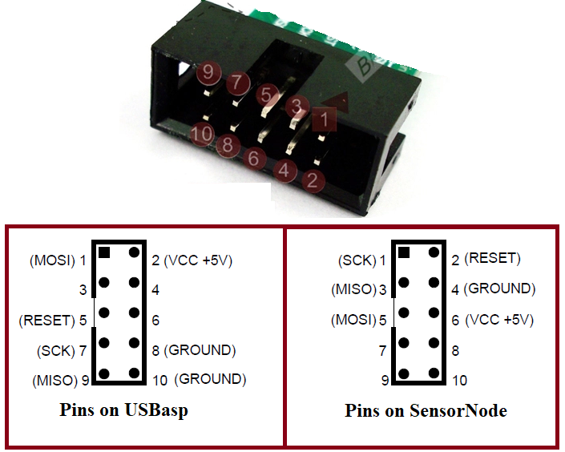
Connect pin on USBasp to Sensor Node
MOSI > MOSI
MISO > MISO
SCK > SCK
RESET > RESET
VCC > VCC
GND > GND

Open Aruidno IDE and open .ino file (updated code).
Choose Board : Arduino Mega 2560 and Processor : ATmega2560
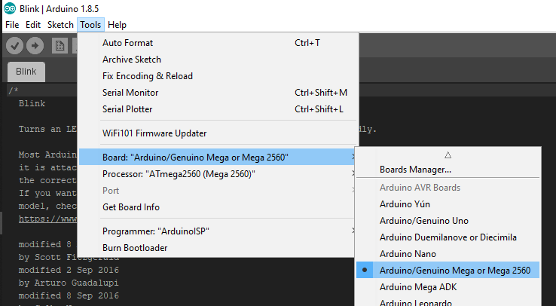

Connect USBasp to computer
Choose Programmer : USBasp and Port COM
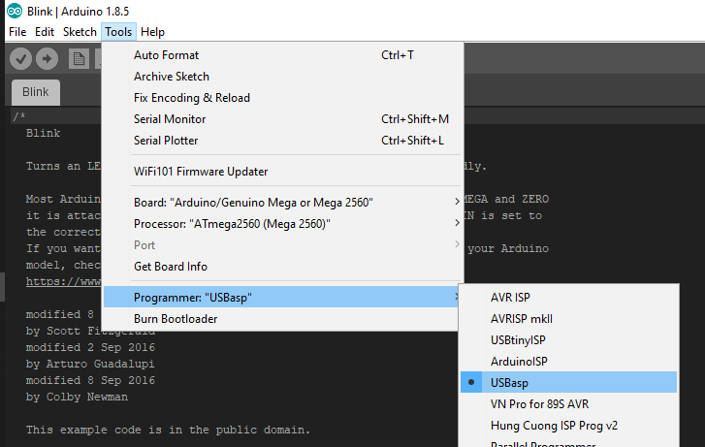
Then click Upload to loading code for ATmega2560 on Sensor Node.
